
2018-2019
Miami-Dade County Public Schools

The School Board of Miami-Dade County, Florida

Ms. Perla Tabares Hantman, Chair
Dr. Michael Karp, Vice Chair
Dr. Dorothy Bendross-Mindingall
Ms. Susie V. Castillo
Dr. Lawrence S. Feldman
Dr. Steve Gallon III
Ms. Lubby Navarro
Dr. Marta Perez
Ms. Maria Tere Rojas

Student Advisor
Mr. Josh Rios

Superintendent of Schools
Mr. Alberto M. Carvalho



The School Board of Miami-Dade County, Florida
1450 N.E. Second Avenue
Miami, Florida 33132

08/22/2018

Table of Contents

A Short History iii

Responsibility of the EESAC iii

Bylaws 1

A. Purpose
A-1 What is a School Advisory Council? 1
A-2 Why does the EESAC exist? 1
A-3 What are the responsibilities of the EESAC? 1

B. Members
B-1 Who are the voting members? 2
B-2 How many alternates are there? 2
B-3 Who is eligible to serve in each category? 2
B-4 Are there any “ex officio” members? 2
B-5 How long is each member’s term of office? 2
B-6 What are the duties of members? 2

C. Elections
C-1 How are teacher, student, parent, and education support employee representatives 3
C-2 Who conducts each election? 3
C-3 How is public notice provided for parent elections? 4
C-4 What process takes place when a vacancy occurs before a
member’s term has expired? 4
C-5 How often does the EESAC elect its officers? 4

D. Meetings
D-1 When, where, and how often are regular meetings held? 4
D-2 How can a special meeting be called? 5
D-3 How can a meeting be cancelled? 5
D-4 How are meeting advertised? 5

E. Agenda
E-1 How does the Chair prepare and distribute the agenda? 5
E-2 How may Council members add items to the agenda? 5
E-3 How may non-Council members suggest agenda items? 5
E-4 How can the agenda be amended? 6

F. Meeting
F-1 How is the meeting conducted? 6
F-2 How many members must be present to constitute a quorum? 6
F-3 What decision-making processes are used? 6
F-4 How should the minutes be handled? 6
F-5 How can non-council members address the EESAC? 7
F-6 What committees, if any, are there? 7

G. Rosters
G-1 What are they? 8
G-2 What are the requirements for the EESAC roster? 8
G-3 What about adult schools? 8
G-4 Must every school include a student? 8
G-5 Are there any exceptions to the EESAC roster composition? 9

H. School Improvement Planning 9

I. Money
I-1 What are the EESAC’s responsibilities with regard to the budget? 10
I-2 What is the EESAC’s role in the use of school recognition money? 10

- Meeting the Five Star requirements through the EESAC 11

- Florida’s Government in the Sunshine 11

- Training and Support 11

Contact Information 12

Appendices

A. EESAC Composition Waiver 14
B. Recommended EESAC Bylaws Template 15
C. Accessing EESAC Fund-Office of Controller Memo 18
D. EESAC Internal Funds Balance Form 6871 20
E. Complimentary Items- Recipient Form 6679 21
F. FL Statutes 1008.36 22
G. Florida’s School Recognition Program Guidelines and Awards 23
H. 2017-2018 Florida School Recognition Award Payroll Procedures 25
I. Florida School Recognition Recommended Guidelines 26
J. 2018-2019 ECCSAC Assurances Checklist 28
K. 2018-2019 SIP Signature Page 29
L. 2018-2019 School Improvement Process Timeline 30
M. Updating Your EESAC Roster 31
N. Posting EESAC Meeting Announcement 32
O. Posting EESAC Minutes 33
P. Facilitator Tool for Problem Solving 34


OVERVIEW

A Short History

The concept of the Educational Excellence School Advisory Councils (EESAC) was first written into Florida state law in 1991 as part of the Blueprint 2000 plan for educational reform and accountability. In 1991, School Advisory Councils (SACs) were entrusted with assisting in the development of the School Improvement Plan. The School Board of Dade County, Florida, embraced these state mandated bodies. In a “Memorandum of Understanding” with the United Teachers of Dade (UTD), adopted in 1996, the School Board renamed the School Advisory Councils Educational Excellence Councils and authorized them to provide all stakeholders with a role in decision making which affects instruction and the delivery of educational programs. The Councils were renamed Educational Excellence School Advisory Councils (EESACs) in 1999 when Blueprint 2000 was revised to become Florida’s High-Quality Education System. At that time, the Councils were also charged with assisting principals in the development of school improvement plans as well as the schools’ budgets.


Responsibility of the EESAC
The EESAC is responsible for final decision-making at the school relating to implementation of the School Improvement Plan (SIP). This authority is delineated in Florida Statute 1001.452(1)(a), in Miami-Dade County School Board Bylaws & Policies (SBBP) 2125 and in Miami-Dade County Public Schools/United Teachers of Dade Contract, Article XXVI, Section 5.

The following compilation of requirements, recommendations, and best practices is designed to guide EESACs in effectively serving their schools while meeting state and school board requirements. Those items required by Florida State Statute (FSS)(FS 1001.452) or by SBBP 2125 are written in bold in this document. Those items that are recommended best practices, but not required, are written in italics.

(Intentionally Left Blank)


Education Excellence School Advisory Councils



(Intentionally Left Blank)


BYLAWS

Each EESAC must develop operating bylaws. Bylaws should be clear, concise descriptions of how the EESAC will function. Individual bylaws must support state laws, school board rules, and the contract with UTD while they enumerate the procedures that are unique to that school.
Bylaws have the force of law. They must be followed, or they must be amended to change the procedures.

Every EESAC should review its bylaws on an annual basis to refresh members’ awareness and to make any needed amendments. It is recommended that the bylaws “Modification Date” be changed every year indicating the bylaws have been reviewed or modified. Individuals authorized by the principal can access bylaws online at http://osi.dadeschools.net. A sample set of bylaws is included in SBBP 2125.

The operating bylaws for each EESAC must include the provision entitled School Bylaws Template B.5. Unexcused Absences, C. Election Process, D.5. Convenient Meeting Time, E. Quorum, F.3. Notice to Members, and H.1. Maintenance of Minutes.
The following outline provides suggestions as to the topics which should be included in the EESAC bylaws.
A. Purpose

A-1 What is the EESAC?
The Education Excellence School Advisory Council (EESAC) is a school-based group intended to represent the school, the community, and those persons closest to the students that shares responsibility for supporting the school’s continuous improvement, Florida Statute 1001.452 (1)(a).

A-2 Why does the EESAC exist?

This authority is delineated in Florida Statute 1001.452(1)(a) and 1008.345, in Miami-Dade County SBBP 2125, and in Miami-Dade County Public Schools/United Teachers of Dade Contract, Article XXVI, Section 4.

A-3 What are the responsibilities of the EESAC?

The EESAC is the sole body responsible for final decision-making at the school relating to implementation of the provision of the state system of improvement and accountability. The EESAC’s additional responsibilities include the following:
- To assist in the preparation, implementation, and evaluation of the School Improvement Plan (SIP);
- To assist in the preparation and evaluation of the school’s annual budget; and
- To recommend waivers or changes to Florida Statute, Florida Board of Education Rules, School Board Bylaws & Policies, and labor contract provisions.

B. Members

B-1 Who are the voting members?

A majority of the members of each school advisory council must be persons who are not employed by the School District (FSS 1001.452(1)(a)).
Each advisory council shall be composed of the principal, the UTD steward, 5 teachers, 1 education support employees, 1 student (Elementary schools not housing grades five and six may include students on their councils), 5 parents, and 3 business and community citizens who are representative of the ethnic, racial, and economic community served by the school (SBBP 2125).
Each council will also add a sufficient number of parents, students, and/or business/community representatives to make the majority of the members of each EESAC persons who are not employed by the District, (i.e. 50% +1). Selection of additional members shall be done in a manner consistent with this policy. Voting Members on the current EESAC roster shall elect officers.

B-2 How many alternates are there?

At least:
1 alternate teacher
1 alternate parent
1 alternate student
1 alternate education support employee

The designated UTD steward may designate an alternate steward in his/or her absence; however, this does not generate an alternate position on the roster. The UTD designated steward may select a different alternate from one meeting to the next.

B-3 Who is eligible to serve in each category?

Each advisory council shall be composed of:
- Teachers, include classroom teachers, student services personnel and media specialists (elected);
- Parents or designated guardians who currently have a child enrolled in the school (elected);
- Students at vocational/adult-technical centers, high schools, middle schools, and elementary schools (housing 5th grade) (elected);
- Education support employee (elected);
- Business/community representatives (appointed);
- UTD designated steward (designated); and
- Principal (designated)

B-4 Are there any “ex officio” members?
No. The principal and the UTD designated steward are required members based on their position at the school.

B-5 How long is each member’s term of office?
Each member’s length of service is determined by each school’s bylaws.

B-6 What are the duties of members?

It is recommended that the school’s EESAC bylaws include the following as duties:
1. Attend all regular and special meetings;
2. Communicate with constituents to collect recommendations/data and opinion for decision-making;
3. Report to constituents the actions taken by the Council; and
4. Consider the needs of all students when making decisions.

C. Elections

C-1 How are teachers, students, parents, and education support employee representatives elected?

Elections shall be conducted in a fair and equitable manner as follows:

- Teachers, parents, students, and education support employees must elect their representatives to the EESAC.
- All full-time and part-time teachers, counselors, media specialists, and permanent subs must have the opportunity to vote for their representatives at a previously announced faculty meeting.
- All educational support employees, including all non-instructional and non-administrative personnel who work at least 20 hours per week, must have an opportunity to vote for their representatives at a previously announced meeting.
- All parents must have the opportunity to vote for their representatives at a meeting that has been advertised at least five (5) working days in advance.
- All students must have an opportunity to vote for their representatives, unless the EESAC bylaws stipulate that an elected Student Council officer will also serve as a member of EESAC.
- The principal appoints business/community representatives and should use this opportunity to balance the ethnic/racial composition of the EESAC.
- Elections must be completed in time so that a fully functioning EESAC is in place at the beginning of the school year.
- Interim elections must be held as stipulated in the bylaws to fill any vacancies that occur during the school year.
- The chair and other officers of the EESAC must be elected from among the EESAC voting members.

C-2 Who conducts each election?

School Board Bylaws & Policy requires the inclusion of the following in each set of bylaws:

The school shall give proper notice of the election of Council members in accordance with Florida’s Government in the Sunshine Law. The school shall also make its best effort to hold elections for each constituent group during hours that are convenient for each constituent group. (FSS and SBBP)

- Teacher elections shall be conducted by the UTD designated Steward in cooperation with the EESAC chair.

- Parent elections shall be held at a time convenient for stakeholders or may be scheduled PRIOR to or AFTER a PTA meeting. The elections should be conducted by the EESAC chair.
- All stakeholder should receive adequate information prior to and during the elections so that they understand the role of the EESAC and the responsibilities of an EESAC member, as well as the qualifications of the candidates for whom they may vote.

C-3 How is public notice provided for parent elections?

The school shall give reasonable notice of the election of Council members in accordance with Florida’s Government in the Sunshine Law. The school shall also make its best effort to hold the elections for each constituent group during hours that are convenient for each constituent group.

C-4 What process takes place when a vacancy occurs before a member’s term has expired?

Specify the process in your bylaws. Once elections have taken place, make updates to your roster online.

Any member who has two consecutive UNEXCUSED absences from council meetings shall be considered as having resigned from the position. The member shall be replaced following election/selection procedures as stated in the bylaws. (FSS)

C-5 How often does the EESAC elect representatives?

Elections are held to fill vacancies according to a school’s bylaws. Ensure that the voting process is delineated in the school’s bylaws. The process should include notification of elections to be held, selection of nominees, the process by which people may vote, and how the results will be posted. Ballots and voting records should be kept by an ESSAC officer and the results documented in the EESAC minutes.

D. Meetings

D-1 When, where, and how often are regular meetings held?

EESACs commonly meet monthly to monitor progress related to the implementation of School Improvement Plan strategies and to make decisions about the budget.

It is required by State Law to include the following in your EESAC bylaws:

All meetings will be held at a time that is convenient to parents, students, teachers, and business/community representatives. (FSS)

It is recommended that you include the following:
All meetings shall be open to the public and shall not be held in any facility, which discriminates based on sex, age, race, creed, color, origin, disability, or economic status or which operates in such a manner as to unreasonably restrict access to such a facility.
EESACs must meet at least four (4) times per year, (quarterly) to approve the School Improvement Plan for the school year, to conduct a midyear review of progress, and to conduct a final assessment of progress.

D-2 How can a special meeting be called?

The principal, chair, or a majority of the Council members may call a special EESAC meeting.

D-3 How can a meeting be cancelled?

The regular council meeting may be cancelled by the Council. All meetings must be cancelled on the Citizen Information Meeting Announcement Webpage. Stipulate the process for cancelling meetings in your bylaws. The bylaws must also reference the quorum required for voting and the number of times per year that you will meet.

D-4 How are meetings advertised?

All meetings (regular and special) must be publicly advertised at least five (5) working days in advance. (FSS)

- A meeting announcement must be posted on the District’s website, http://www.dadeschools.net under “Meetings,” and
- Advertisements must be posted and distributed within the school community so that all interested persons are aware of the meeting.

All meetings shall be open to the public and shall not be held in any facility or location which discriminates on the basis of sex, age, race, creed, color, origin, disability, or economic status or which operates in such a manner as to unreasonably restrict access to such a facility.

E. Agenda

It is required by state law to include the following: (FSS)
All members must receive at least three days’ advance notice in writing of any matter that is scheduled to come before the Council for a vote.

It is also HIGHLY recommended that all meetings include discussions and or presentations on the status of the SIP and student achievement.

E-1 How does the Chair prepare and distribute the agenda?

The chair, in consultation with the principal and EESAC members, shall prepare and distribute the agenda for all regular and special meetings. The agenda should be distributed and posted prior to the meeting.

E-2 How may Council members add items to the agenda?

Council members may add items to any regular meeting agenda by contacting the Chair in advance.

E-3 How may non-Council members suggest agenda items?

Non-council members may propose an agenda item by contacting a Council member.

E-4 How can the agenda be amended?

The agenda may be amended at the meeting by majority vote. Each school’s bylaws should provide specific information on this process.

F. MEETING

F-1 How is the meeting conducted?

The chair conducts the meeting following the agenda providing an opportunity for all members to participate in decision-making, and giving members of the public the opportunity to address the EESAC. Schools are encouraged to establish a parliamentary guide in order to assure consistency in conducting EESAC meetings. This process should be stipulated in the bylaws.

Following procedures outlined in the bylaws, most EESACs seek to make decisions by consensus, voting only when there is not time or opportunity to reach consensus.
“Consensus will aim for the maximum agreement among people while drawing on as much of everyone's ideas as possible.”
Since meetings can involve many members and non-members, it is a very good practice to create name cards/tags for each member. This helps members to know one another and quickly identifies any non-members who may be present.

F-2 How many members must be present to constitute a QUORUM?

It is required by state law to include at least the following in your bylaws:
A majority of the voting members of the Council shall constitute a quorum. A quorum must be present before a vote is taken. (FSS)
- If a voting member is not present, the alternate for that position is the voting member for that meeting.
- An alternate may only be counted towards the quorum if the voting member that they represent is NOT present at the meeting; and
- Assistant principals may only serve as the alternate to the principal if a waiver has been submitted and approved by the District EESAC Support Committee.

F-3 What decision-making processes are used?

It is recommended that you include the following in your bylaws:
The primary method of decision-making shall be by consensus. (SBBP)
Consensus seeks the agreement of most participants while including every member’s opinions as much as possible.

F-4 How should MINUTES be handled?

Minutes must be kept for every meeting of the EESAC (FSS). Minutes should include the name of the school, a list of those in attendance, the date and location of the meeting, an official call to order, old and new business, the date and location of the next meeting, and the time the meeting adjourned. Any actions items voted on by the SAC should also be reflected in the minutes.

All decisions must be recorded exactly in the minutes. If a vote is taken, the results must be recorded by listing the names of the members who voted in favor and those who voted against. By law, all members who are present must vote. The only exception is for a member who has a conflict of interest. That member must declare the conflict and abstain from voting.

The EESAC may elect one of its members to be the recording secretary, a clerical person may be assigned by the principal to this responsibility, or some other process may be followed. Posting authority of the minutes must be given by the principal through online access.

Minutes, including tape recordings made of the meetings, are public records. They must be saved and must be made available to any member of the public who requests them. The process to maintain minutes is:

- Following the meeting, the designated secretary goes online to http://osi.dadeschools.net and posts the minutes.

- It is recommended that the minutes be posted within 7 working days of the meeting.

- At its next meeting the EESAC approves or amends the minutes. The designated secretary will then make any necessary corrections to the online draft.

- The principal must then go online to verify the approved minutes, using the verification code issued by the Office of School Improvement.

- EESAC minutes, both pending and verified, may be viewed at: http://osp.dadeschools.net/products/ONLINE/info/infopickschool.asp?rep=eesac

F-5 How can non-council members address the EESAC?

Members of the public can address the EESAC by contacting a Council member. Those who are in attendance at Council meetings shall be provided with an opportunity to discuss issues under consideration as specified in the school’s bylaws.

F-6 What committees, if any, are there?

A standing committee may oversee ongoing issues and/or programs during the school year. School established committees, which must include discipline and safety, are to be allowed to report to the EESAC on a regular basis.
The members of the committee can be both members and non-members of the EESAC. Membership should be open to all stakeholders.

List any standing committees, including their responsibilities, and make provisions to establish special committees. Include guidelines for composition which ensures balanced participation. School established committees, which must include discipline and safety, are to be allowed to report to the EESAC on a regular basis. (SBBP)
Members of the committees do not have to be elected to the EESAC.

G. Rosters

G-1 What are they?

EESAC rosters list all voting members and alternates along with their demographic information.

An official roster is presented to the School Board each year for approval per Florida State Statute. The deadline for schools to complete and verify this roster is set on an annual basis.

Once rosters are approved by the School Board, the district can certify to the Florida Department of Education that every Miami-Dade County Public School has a school advisory council that meets all the stipulations of state law.

Throughout the year the EESAC roster must be updated at http://osi.dadeschools.net whenever vacancies and new elections take place. These updates are documented as the “Current Roster.”

G-2 What are the requirements for the EESAC Roster?

As required by school board rule (SBBP) each EESAC must:
- Begin with the following minimum membership:
Five (5) teachers and one (1) alternate teacher,
Five (5) parents and one (1) alternate parent,
One (1) education support employee and one (1) alternate,
One (1) student and one (1) alternate student (Elementary schools with 5th grade.),
Three (3) business/community representatives, the UTD designated building steward, and the principal;
- Add enough persons who do not work at the District so that the non-district employees form the majority;
- Demonstrate that the EESAC is reflective of the ethnic, racial, linguistic, disabled, and economic community served by the school;
- Include at least one representative (parent, teacher or administrator) for Students with Disabilities (SWD); and
- Equitably include parents of ELL students.

G-3 What about adult schools?

- Adult programs that share a facility with a K-12 school will add the adult school principal (as applicable), a teacher, the UTD designated steward (as applicable), and a student to the K-12 school’s EESAC.
- Stand-alone adult schools follow the requirements for K-12 schools, but they are not required to include parent representatives.

G-4 Must every school include a student?

Yes. Councils of vocational/adult-technical centers, high schools, middle schools, and elementary schools containing grades five and/or six shall include students. Elementary schools not housing grades five and six may include students on their councils. Elementary schools may include no more than one (1) student representative. All students at each of the vocational/adult technical, senior high, middle or elementary schools must be given an opportunity to elect their representative to the EESAC. Each school may establish its own nomination and election procedures. (SBBP)

G-5 Are there any exceptions to the roster composition?
The EESAC may submit a request with explanation to the EESAC Support Committee, as established by the Superintendent, using FM-7292, to increase or decrease the number of representatives in one, several, or all the groups for which representation is required. The EESAC Support Committee will make recommendations to the Superintendent regarding the appropriateness of the request. The specific request to increase or decrease EESAC representation must be approved by a majority vote of the council prior to submission to the EESAC Support Committee for consideration. Requests for an increase or decrease in EESAC representation, when approved by the EESAC Support Committee, will remain in effect until a new composition or procedural requirement is requested and approved by the EESAC Support Committee. Once the Support Committee approves the waiver, the EESAC bylaws must be amended to reflect the change in membership.

As required by law, the principal must remain a member of the EESAC and must participate fully in all council meetings and decision-making processes. When, because of an unavoidable conflict, the assistant principal acts as an alternate for the principal, (with an approved Composition Waiver), the assistant principal will have full authority to speak and to participate in all decision-making processes. Decisions made by the EESAC are binding.

H. School Improvement Planning

The EESAC is the sole body responsible for developing and monitoring final decision making at the school relating to the implementation of the School Improvement Plan. (FSS)
In accomplish its charge, the EESAC should:

- Schedule and conduct meetings on a regular basis;
- Review all applicable student performance data;
- Determine the students’ needs and prioritize them;
- Recommend strategies to improve areas of need;
- Decide how to measure results;
- Assist in the preparation and evaluation of the School Improvement Plan/Process;
- Meet all District and State timelines; and
- Document data analysis and SIP reviews in the EESAC minutes.

The EESAC must give the final approval of the SIP, the Mid-Year Review as applicable, and the End-of-Year Review. In addition, the EESAC should receive regular reports on the implementation steps and progress towards meeting the outcome statements.

Some EESACs form subcommittees to monitor the implementation plan. The subcommittees can include members of the EESAC as well as other non-members who are familiar with the various aspects of the school’s programs.

I. Money


I-1 What are the EESAC’s responsibilities with regard to the budget?

The EESAC must advise the principal in the development of the school’s budget. (FSS) To accomplish this, the EESAC should receive budget training.

Budget training can be provided by the school’s principal, by the budget analyst assigned to the school from the District, or by some other administrator.

A portion of the school’s budget is an allocation of $5.00 for every FTE in the school, made directly to the EESAC. This money may not be used on capital improvements; nor may they be used for any project or program that has duration of more than one (1) year. Neither District staff nor the principal may override the decision of the EESAC with regard to these funds. (F.S. 24.121)

The Controller for Miami-Dade County Public Schools has created a procedure for accessing EESAC funds for small purchases through the school’s internal fund. Decisions and directions for the use of this set-aside fund should be made at the beginning of the school year and should be noted in the EESAC minutes. A copy of the Controller’s directive is included in the Appendices.

Copies of the entire school budget, not just the EESAC portion, should be provided to all EESAC members. Budget decisions and implementation timelines should be tracked through the EESAC’s minutes.

I-2 What is the EESAC’s role in the use of School Recognition money?

Every Florida school that receives a performance grade of “A” or improves one letter grade will receive School Recognition money. These funds may be spent on staff bonuses, temporary personnel, or educational equipment and materials.

Funds from the school recognition program cannot be utilized for the purchase of T-shirts, parties for students, field trips or any other similar type of activity as per M-DCPS, Office of Budget Management (Refer to Appendices for Memorandum RYS:04).

The decision on how to spend School Recognition money must be made jointly by the EESAC and the staff of the school. If a decision has not been reached by February 1, the award will be equally distributed in bonuses to classroom teachers who are currently teaching in the school.

The legislature did not designate a process for a school to follow in order to have the staff and the EESAC reach agreement about School Recognition money. A good practice is to design a process and an agreement on how conflicts will be resolved before the school receives this award. When considering how to distribute bonus money, EESACs are encouraged to consider staff who are currently employed at the school as well as former employees who were part of the school when the improved performance took place.


J. Meeting the Five Star requirements through the EESAC

The Five Star School Award was created by the Commissioner's Community Involvement Council and is presented annually to those schools that have shown evidence of exemplary community involvement. In order to earn FIVE STAR school recognition, a school must show documentation that it has achieved 100% of the established criteria in the categories of:
- Business Partnerships
- Family Involvement
- Volunteerism
- Student Community Service
- School Advisory Councils

For assistance, please contact: Office of Community Engagement, https://www.engagemiamidade.net/community-five-star-school

K. Florida’s Government-in-the-Sunshine

As a public body, all EESACs are subject to the requirements of Florida’s Government-in-the- Sunshine. This requires public access to the EESAC and to its public records. The requirements regarding public notice of meetings, opportunity for public input at meetings, and the maintenance of minutes as public records have been addressed in earlier sections of this guide.

In addition, the Sunshine Law requires:

- No Secret Ballots - all votes must be made publicly and must be recorded in the minutes.

- No Secret Meetings - no members of the EESAC may discuss privately any issue that will come before the EESAC for a vote.

There are civil and criminal penalties for violations of the Sunshine Law.
The Sunshine Law can be obtained from: http://myfloridalegal.com/webfiles.nsf/WF/MNOS-AKBS9L/$file/2017+Sunshine+Law+Manual.pdf
L. Training and Support
To provide assistance in identifying resources and strategies necessary for the development and implementation of the School Improvement Plan or to provide professional development activities in support of consensus decision making, training and support are available from the Office of School Improvement, UTD, Region Offices, and the Office of Labor Relations.

To assist in the resolution of conflicts, appropriate joint support may be provided upon the request of the principal, UTD, or the EESAC to the District EESAC Support Committee and upon notification to the Regional Superintendent.

To resolve unsuccessful conflicts, final intervention may be requested from the EESAC Support Committee which will make recommendations to the Superintendent.

Contact Information:

Office of Labor Relations, 305-995-1590

North Region Center, 305-572-2800

Central Region Center, 305-499-5050

South Region Center, 305-252-3041

Education Transformation Office (ETO), 305-995-3091

Division of Exceptional Student Education, 305-995-1721

United Teachers of Dade (UTD), 305-854-0220

APPENDICES

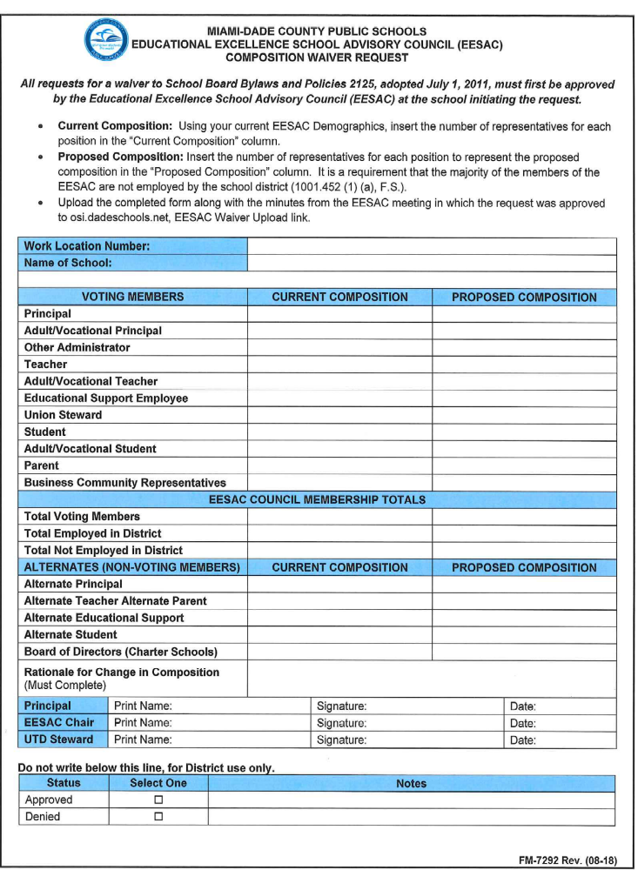

RECOMMENDED TEMPLATE AS FOUND IN SBBP 2125
Educational Excellence School Advisory Council Bylaws
Each Educational Excellence School Advisory Council can include in its operating bylaws provisions similar to those described herein. However, the operating bylaws for each Educational Excellence School Advisory Council must include the provision herein entitled IV.B.5. Unexcused Absences, IV.C. Election Process, IV.D.5. Convenient Meeting Time, IV.E. Quorum, IV.F.3. Notice to Members, and IV.H.1. Maintenance of Minutes
 | A. | Purpose
 |  | The purpose of the ________ School EESAC is to work to ensure improved student achievement. One of the ways the Council will do this is by preparing and evaluating the school improvement plan as required by F.S. 1008.345, Comprehensive Revision of Florida’s System of School Improvement and Education Accountability.
 | B. | Council Members

 |  | 1. | Composition
 |  |  | The _________ Council shall include ___ teachers, ___parents, ___ students, ___ education support employees, ___business/community representatives, the UTD designated steward and the principal. With the exception of the principal, the UTD designated steward, and the business/community representatives, all other members shall be elected by their constituent groups. Teachers, parents, students, and education support employees shall elect an alternate representative. The designated steward may designate an alternate steward in their absence. The council will be representative of the ethnic, racial, linguistic, disabled, and economic community served by _________ School. A majority (fifty percent (50%) plus one (1)) of members must not be employed by the District. (Note: Refer to Composition and Procedural Requirements for required minimums as well as procedures to seek variations or expansion.)
 |  | 2. | Eligibility
 |  |  | All teachers, student services personnel, and the media specialist employed by the school are eligible to be elected teacher representatives to the council. All other persons employed by the school, including paraprofessionals, and those who are not defined as instructional or administrative personnel and whose duties require twenty (20) or more hours in each normal working week are eligible to be elected as the education support employee representative. All parents, guardians, or significant others responsible for a child enrolled in __________ School are eligible to be elected as parent representatives, with the exception of those parents who are also employed by __________ School.
 |  | 3. | Terms
 |  |  | The terms of office shall begin on _______ and end on ________. (Note: This may be different for the different subgroups of the council. Consideration may be given to having parents elected to staggered terms. Teachers may be elected for the three (3) year period which corresponds to the teacher contract.)
 |  | 4. | Responsibilities
 |  |  | Council members are expected to:

 |  |  | a. | attend all regular and special meetings,
 |  |  | b. | communicate with constituents to collect data and opinions for decision making,
 |  |  | c. | report to constituents the actions taken by the council, and
 |  |  | d. | consider the needs of all students when making decisions.

 |  | 5. | Unexcused Absences
 |  |  | Any member who has two consecutive unexcused absences from council meetings shall be considered to have resigned. The member shall be replaced following election/selection procedures as stated in these bylaws.

 | C. | Election Process
 |  | (Outline here the process by which teachers, parents, students, and education support employees will be nominated and elected to office, as well as a process to fill vacancies. An additional section could describe how the chair will be elected.) The school shall give proper notice of the election of council members according to the Sunshine Law. The school shall also make its best effort to hold elections for each constituent group during hours that are convenient for each constituent group.
 | D. | Meetings

 |  | 1. | Regular Meetings
 |  |  | The regular meetings of the council will be held on the ___ day of each month. The meetings will be held in ____________ at ________________.
 |  | 2. | Special Meetings
 |  |  | In the event a special meeting is needed, the principal, chair or a majority of council members may call a meeting.
 |  | 3. | Cancellation - A regular council meeting may be canceled by the council.
 |  | 4. | All meetings shall be open to the public and shall not be held in any facility or location which discriminates on the basis of sex, age, race, creed, color, origin, disability, or economic status or which operates in such a manner as to unreasonably restrict access to such a facility.
 |  | 5. | Convenient Meeting Time
 |  |  | All meetings will be held at a time that is convenient to parents, students, teachers, and business/community representatives.

 | E. | Quorum
 |  | A majority of the voting members of the council (or the alternates representing absent voting members) shall constitute a quorum. A quorum must be present before a vote may be taken.
 | F. | Agenda

 |  | 1. | The chair shall prepare and distribute the agenda for all regular and special meetings.
 |  | 2. | Adding to the Agenda

 |  |  | a. | Council members may add items to any regular meeting agenda by contacting the chair in advance.
 |  |  | b. | Non-council members may propose an agenda item by contacting a council member.
 |  |  | c. | The agenda may be amended at the meeting by majority vote.

 |  | 3. | Notice to Members
 |  |  | All members must receive at least three (3) days’ advance notice in writing of any matter that is scheduled to come before the council for a vote.

 | G. | Consensus Decision Making
 |  | The primary method of decision making shall be by consensus. Consensus seeks the agreement of the most participants while including every member’s opinions as much as possible.
 | H. | Minutes

 |  | 1. | Maintenance of Minutes
 |  |  | Minutes shall be kept for all meetings of the EESAC. Copies of the approved minutes shall be maintained by the school as a permanent record. In addition, beginning July 1, 2002, a copy of the minutes of every meeting will be provided electronically to the designated District website.
 |  | 2. | Content
 |  |  | The minutes shall include the names of those in attendance and any actions taken by the council. The minutes shall be approved at the next regular meeting of the council and an official copy kept on file in _______________.

 | I. | Input from Non-Council Members
 |  | Those who attend the council meetings shall be allowed to discuss issues under consideration in the following manner:
 |  | (Describe how this can be done. Consider a specified time at the end of each meeting.)
 | J. | Committees
 |  | (List any standing committees, including their responsibilities, and make provisions to establish special committees. Include guidelines for composition which ensures balanced participation.) School established committees, which must include discipline and safety, are to be allowed to report to the EESAC on a regular basis.
 | K. | Amendments
 |  | These bylaws may be amended at any regular meeting by a 2/3 vote of the membership of the EESAC, provided that at least five (5) working days written notice of the proposed change has been given to all members of the council.
F.S. 1001.42(18)(a)(b), 1001.42(19)(c), 1001.452, 1008.345
F.A.C. 6A-1.09982





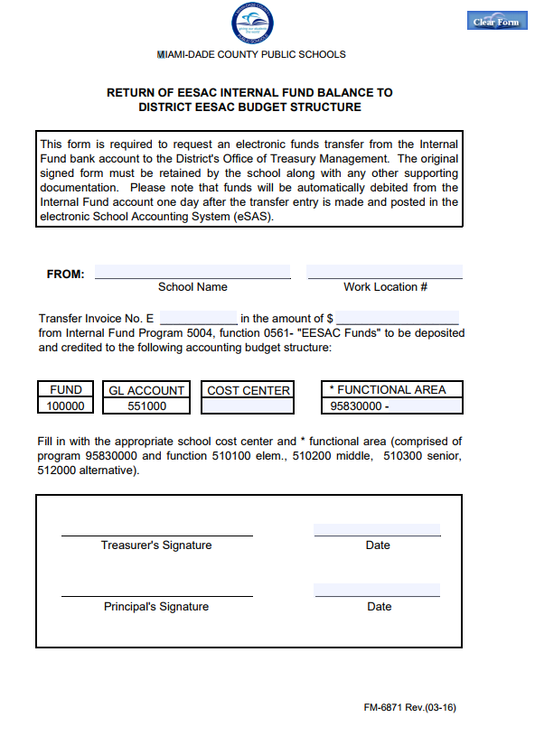

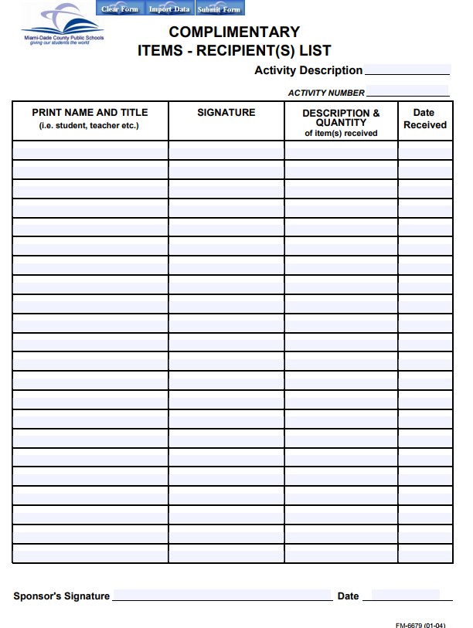


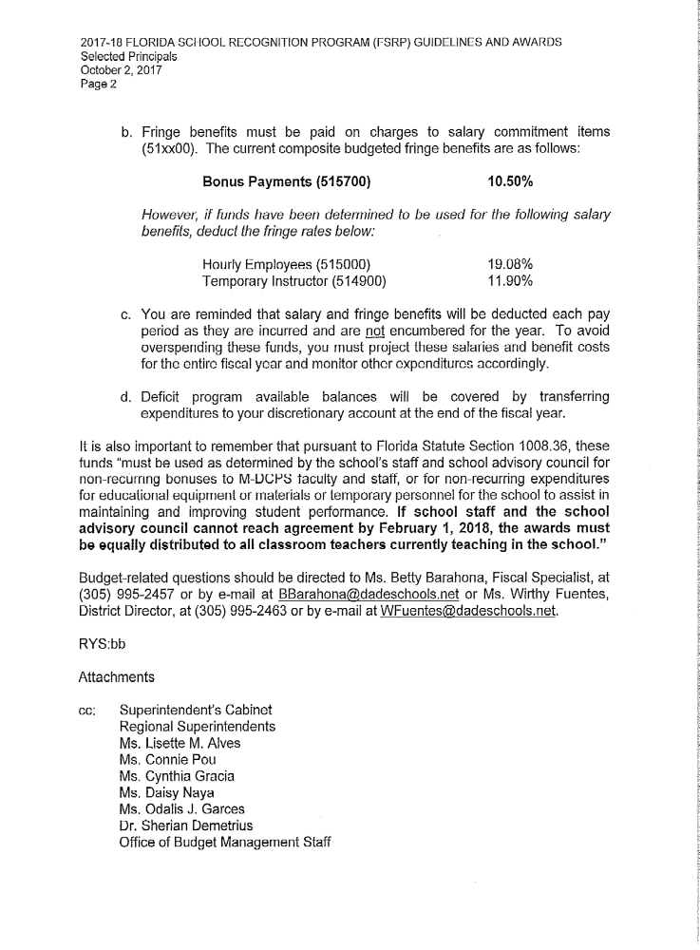


MIAMI-DADE COUNTY PUBLIC SCHOOLS
Florida School Recognition Program
Recommended Guidelines

- Review and share with EESAC, staff, and stakeholders Florida Statute 1008.36, terms, and budget requirements that directly relate to Florida School Recognition Program (FSRP)
  - Schedule meetings for EESAC and staff
  - Advise all stakeholders that the amount of money awarded is pending
  - Clarify the roles of EESAC and the staff in determining the distribution of the FSRP’s fund
  - Establish a timeline for the development and approval of the plan (Submission deadline to OSI of the District School Recognition Plan/Final Verification, Friday, January 18, 2019)
- Solicit involvement (Principal, EESAC Chair and designated UTD Steward) from all EESAC and staff members in the planning process to form a committee to determine distribution of dollars
  - Ensure adequate representation from instructional and non-instructional, parent, and community representatives
- Schedule meetings to facilitate the development of the plan(s)
  - Provide sample plans or previously accepted funded distribution plans
  - Provide a list of all possible recipients (full-time, part-time, retirees, on leave, deceased, transfers, surplus)
  - Determine which individuals and/or groups may submit a plan to the committee within an established timeline
- Schedule a general staff meeting so the committee may present their plan(s)
  - Post meeting on the district calendar no fewer than 5 days in advance
  - Publish plan(s) to the staff at least 5 days in advance of the meeting where the final vote will occur
  - Vote on the plan(s) until one plan is accepted by a simple majority (50% plus 1) of the people present at the meeting
    - Require sign-in sheets and secret ballots
    - Counting should be done by UTD Steward, EESAC Chair, and any other interested observer and voting results should be posted immediately
- Present and approve the final proposed plan at a scheduled EESAC meeting by Friday, January 18, 2019
- Review and confirm payroll distribution (Principal, EESAC Chair, and designated UTD Steward) prior to submission in order to eliminate mistakes

  - Review previous year’s Table of Authorized Positions (TAPs) if distribution involves previous staff
- Your school will receive instructions from the Budget and Payroll offices to assure completion requirements.
- Submit appropriate forms to designated office(s), if plan involves non-salaried expenditure (This will remain as pending until your school receives instructions from the Budget and Payroll offices.)
- Complete District School Recognition Plan/Final Verification page, scan and upload to osdadeschool.net by Friday, January 18, 2019.
- Archive a description of the process used to arrive at the plan, voting ballots and results, payroll records and fund expenditures for auditing purposes

REMINDER - “If school staff and the school advisory council cannot reach agreement by February 1, 2019, the awards must be equally distributed to all classroom teachers currently teaching in the school.” http://www.fldoe.org/evaluation/geninfo.asp

If you need additional assistance, please contact a staff member from the Office of School Improvement:

Ms. Iliana Ramos-Sibila 30-995-2347, iSibila@dadeschools.net
Dr. Sherian Demetrius, 305-995-7046, sdemetrius@dadeschools.net
Ms. Ana D’Atri, 305-995-2347, anamaria@dadeschools.net


2018-2019 EESAC Assurances Checklist
Educational Excellence School Advisory Committee Compliance

Work Location#: ____________ School Name: _________________________________________

By checking the items below, the school ensures that the Educational Excellence School Advisory Committee (EESAC) will be in compliance with School Board Bylaws & Policy (SBBP) and State Statutes for the 2018-2019 school year.

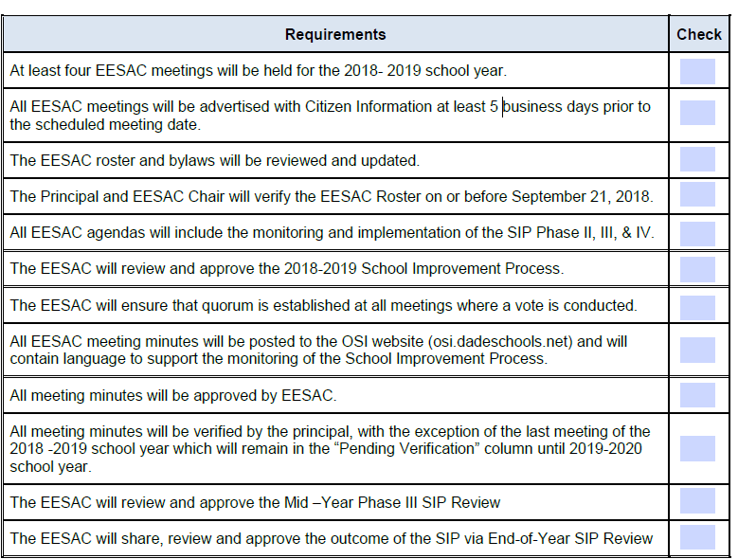
The signatures below confirm that all items listed above will be completed during the 2018-2019 school year.
Principal | Print Name: | Signature: | Date:
EESAC Chair | Print Name: | Signature: | Date:
UTD Designated Steward | Print Name: | Signature: | Date:
Upload the 2018-2019 EESAC Assurances Checklist to the “2017-2018 EESAC Assurances Checklist Upload” link found at http://osi.dadeschools.net, on or before Friday, September 28, 2018.

School Improvement Process (SIP) Signature Page
2018-2019

School Name: ____________________________________ Work Location #: _______
Date of Final Review: ____________________________________________________

This School Improvement Process has been reviewed cooperatively by administrators, teachers, parents, students, business/community representatives, and UTD designated stewards.

The original signature page, including signatures of all persons listed below, is on file at the Region Office. A copy of this signature page should be kept on file at the school site.

Required Signatures

Principal | Print Name: | Signature: | Date:
EESAC Chair | Print Name: | Signature: | Date:
UTD Designated Steward | Print Name: | Signature: | Date:
EESAC Parent Representative | Print Name: | Signature: | Date:
EESAC Business/Community Representative | Print Name: | Signature: | Date:
EESAC Student Representative  (as applicable) | Print Name: | Signature: | Date:

Additionally, the signature of the Region Office Superintendent/Region Directors certifies that this SIP has been reviewed by appropriate personnel to ensure compliance with State and District rules.

Region Office Superintendent or  Region Director | Print Name: | Signature: | Date:

The 2018-2019 SIP Signature Page is due (hand delivered) to the Region Office on or before Friday, September 14, 2018.

School Improvement Process Timeline
2018-2019

UPDATING THE EESAC ROSTER
- Log on to: http://osi.dadeschools.net/
- On the Left-hand menu bar: “EESAC” select Edit Minutes/Bylaws/Rosters
- Enter the school’s 4-digit work location number
- Select your name from the Staff Member list and enter the last 4 digits of your SSN in the box next to “Edit EESAC Roster”
- If the EESAC chair is NOT employed by the District, scroll down to the middle of the page to the category “EESAC Chair:” Type the 8 character EESAC Chair verification ID in the space provided: “Edit the EESAC Roster”
- On the left-hand side menu bar, select Add Member to add a new member to the roster
- Enter the following field for the council member: First name, middle initial & last name
- Select the group the member represents
- Indicate if the member is the Chair or Board of Directors chair (Charter Schools)
- Enter the date when the EESAC member was elected or re-elected (month, day, year)
- Select gender
- Select primary ethnicity
- Indicate if the member is: the parent of an English Language Learner (ELL) student at this school
- Indicate if the member is: employed in the M-DCPS District (All charter school employees are considered “Employed by the District”)
- Indicate if the member is: an Exceptional Student Education (ESE) representative
- Click: Save new member information [Reminder: entries must be made one at a time]
- To modify/delete a member, select Modify/Delete Member from the left-hand menu bar- process one member at a time

POSTING EESAC MEETING ANNOUNCEMENT
(Must have a M-DCPS Employee Number)

- Log on to: http://osi.dadeschools.net/
- On the Left-hand menu bar, below EESAC:
- Select Post Meetings
- Fill in the required fields: Employee Number, Birth Month/year, E-Mail Address then click ENTER
- Verify that the ‘Required Information’ is correct
- From the drop-down menu for Category, select ‘School Meeting’
- Enter the following: Meeting date; meeting Time – (a.m. / p.m.) (Meeting end time is optional)
- School/Department: Enter the WORK LOCATION NUMBER followed by the school’s name (do not include “#” or the letters “WL”)
- Address & Room: Enter the school’s address and the room in which the meeting will be held
- Subject: EESAC Meeting or Provide a brief outline/summary of the topics (Agenda items) to be covered during the meeting
- Contact Person: Enter your name
- Telephone: Enter your school’s telephone number
- Click: Add meeting
- Save and print the confirmation notice, you will need it to cancel or update the meeting announcement
POSTING EESAC MINUTES
(SHOULD BE POSTED 5 DAYS PRIOR TO THE MEETING)
- Log on to: http://osi.dadeschools.net/
- On the Left-hand menu bar, below EESAC: Select Edit Minutes/Bylaws/Rosters
- Enter the school’s 4-digit work location number
- Select your name from the Staff Member list and enter the last 4 digits of your SSN in the box next to “Edit EESAC Minutes”
- If the EESAC chair is NOT employed by the District, scroll down to the middle of the page to the category “EESAC Chair”: Type the 8 character EESAC Chair verification ID in the space provided and click on “Edit EESAC Minutes”
- Use the Pull-Down option to select the date (Month, Day, and Year) and time of the meeting (hour, minute, time) - Click to add a new minutes entry
- Fill in the following: (a) The name of the recording secretary (b) Where the meeting took place
- Quorum: Indicate if quorum was established for this meeting
- Florida Sunshine Law compliance:
Was Citizens’ Information notified? (Yes/No)
You must have the confirmation sheet that was generated when you posted the meeting to Citizen’s Information.
Date Citizen’s Information was notified (Month, Day, and year)
- Attendance: In the first box- Members Present, cut the names of those members who were absent from that meeting and add them to the second & third boxes- as appropriate - Members not Present –Excused & Unexcused
- Others Present: list all non-voting members who are present
- Topics/Outcomes Discussed: Provide a concise yet detailed summary of the topics covered based on your agenda and the decisions taken. If a vote was taken, the minutes must include how each member voted
- Click and save the entry

Non-Discrimination Policy

The School Board of Miami-Dade County, Florida adheres to a policy of nondiscrimination in employment and educational programs/activities and strives affirmatively to provide equal opportunity for all as required by:

Title VI of the Civil Rights Act of 1964 - prohibits discrimination on the basis of race, color, religion, or national origin.

Title VII of the Civil Rights Act of 1964 as amended - prohibits discrimination in employment on the basis of race, color, religion, gender, or national origin.

Title IX of the Education Amendments of 1972 - prohibits discrimination on the basis of gender.

Age Discrimination in Employment Act of 1967 (ADEA) as amended - prohibits discrimination on the basis of age with respect to individuals who are at least 40.

The Equal Pay Act of 1963 as amended - prohibits gender discrimination in payment of wages to women and men performing substantially equal work in the same establishment.

Section 504 of the Rehabilitation Act of 1973 - prohibits discrimination against the disabled.
Americans with Disabilities Act of 1990 (ADA) - prohibits discrimination against individuals with disabilities in employment, public service, public accommodations and telecommunications.

The Family and Medical Leave Act of 1993 (FMLA) - requires covered employers to provide up to 12 weeks of unpaid, job-protected leave to "eligible" employees for certain family and medical reasons.

The Pregnancy Discrimination Act of 1978 - prohibits discrimination in employment on the basis of pregnancy, childbirth, or related medical conditions.

Florida Educational Equity Act (FEEA) - prohibits discrimination on the basis of race, gender, national origin, marital status, or handicap against a student or employee.

Florida Civil Rights Act of 1992 - secures for all individuals within the state freedom from discrimination because of race, color, religion, sex, national origin, age, handicap, or marital status.

Title II of the Genetic Information Nondiscrimination Act of 2008 (GINA) - Prohibits discrimination against employees or applicants because of genetic information.
Veterans are provided re-employment rights in accordance with P.L. 93-508 (Federal Law) and Section 205.07 (Florida Statutes), which stipulate categorical preferences for employment.

School Board Policies 1362, 3362, 4362, and 5517 prohibit harassment and/or discrimination against students, employees, or applicants on the basis of sex, race, color, ethnic or national origin, religion, marital status, disability, genetic information, age, political beliefs, sexual orientation, gender, gender identification, social and family background, linguistic preference, pregnancy, and any other legally prohibited basis. Retaliation for engaging in a protected activity is also prohibited. Revised 07/2011

