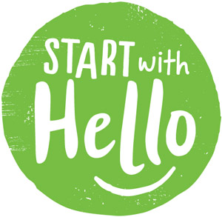
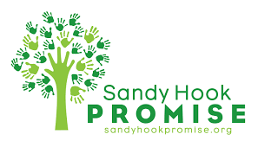

Sandy Hook Promise aims to raise awareness and educate students on how to reduce social isolation and create a more connected and inclusive school and community overall.

Help promote Start with Hello Week at (INSERT SCHOOL NAME HERE) by joining us for daily events to encourage a more united school and community!

START WITH HELLO WEEK DAILY THEMES:

Monday, September 19th: “Hey Day”

Tuesday, September 20th: “Positivity Tuesday”

Wednesday, September 21st: “Make Miami Green”

Thursday, September 22nd: “Miami-Dade Mingles”

Friday, September 23rd: “Forget Me Not Friday”

Share your photos on Instagram and Twitter using the following hashtags:

#MiamiStartsWithHello
#(SCHOOLNAME)StartsWithHello

